[**Software Testing Simple (Software Quality Assurance QA)**](https://www.udemy.com/course/software-testing-simple/)

Sumber: <https://www.udemy.com/course/software-testing-simple>

Types of testing:

Ad-hoc testing /monkey testing : Monkey testing (sometimes called by exploratory testing) is a type of testing randomly with purpose to break the system.

Types of test cases:

Smoke Testing : the terms comes from hardware process. When we build a PC, after assembling, we need to test can it be turned on. Before we install OS etc, make sure it could run, and no smoke is appear. Same thing goes, in smoke testing we make sure there is no “smoke” in our app. Usually smoke test is a short-step yet critical.

Sanity Testing : sanity test is a type of test based on story but not in in-depth. For example if we have a story that when we click button then the color is change to blue, then we just make sure that the button color is changed. You don’t need to test whether we can checkout the product, check it on many pages, etc. so it is a type of lightweight testing.

Bug Priority Classes:

Low : bug that don’t interrupt the apps process. Sometimes user don’t think that it is the bug. But still we better keep documented it. Though during triaging, the bug would be sent to backlog, and maybe can be fixed in a very long time because we have new requirement, or high priority bug.

medium : lower than high priority bug, usually it is a bug that block process but we can find the alternative, or the bug is not according to the story requirement. Usually it can be fixed by tomorrow or later on/

High : a bug that make apps broken. It is a type of bug that need to be fixed immediately, and can block our testing process.

Bug priority tips:

We can divide bug priority by making quadrant based on severity and priority.  
1. High priority, critical severity: bug that need to be solved ASAP. For example cannot login to blibli, or search function is not working.

2. High Priority but non critical: bug that need to be solved because it violates against company/product condition, but it really don’t blocking the app process. For example if the company logo color is wrong which don’t describe our company itself.

3. low priority but critical: bug that need to be solved but it’s rarely used, so it can be compromised. For example if bulk approval process is not working, though it’s rarely used and user can use another way besides bulk approval so it can be decided when to fix that.

4. low priority, non critical : as it describes, it’s a bug that not really violates business process, usually it can be set to low bug severity. For example a caption in image is in the wrong font.

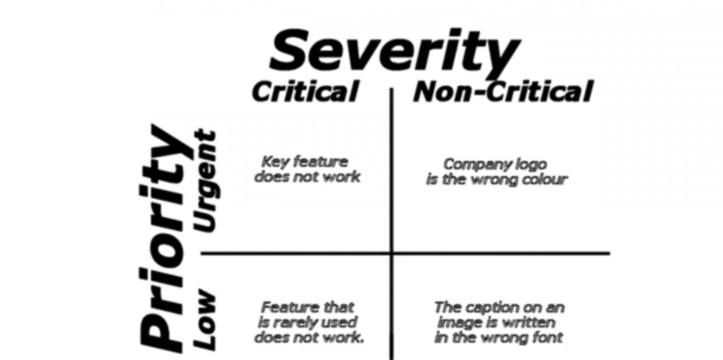

Regression Choice:

Retest All: this type of regression means we would test all possible cases in our apps. Supposed we have 200 cases, then we should test all 200. This is the most expensive, exhausting, and takes time to do.

Regression test selection:

This is a types of regression that make sure the unmodified part of the program is error free. For example if we develop login method, then we need to add sign up case to make sure the sign up feature is working.

Prioritization of test case:

Selection of test case based on the business impact, critical, and frequently used functionalities. With this method, this can greatly reduce the regression of test suite. For example we should add create RMA as part of regression since is the most critical feature.